My address is 13 Spittal Street, apartment 3F2, EH3 9DY, Edinburgh
How to pick up keys

For a flexible and convenient check-in, I have left the keys in a lockbox outside the apartment building. Here are some easy steps to guide you through the self-check in:

Step 1: Please arrive safely at 13 Spittal Street, EH3 9DY Edinburgh.

Step 2: The lock box is located just to the right-hand side of our front door (13 Spittal Street). The “Master Lock” has a 4 digit code “7717”.

IMPORTANT: Please set the code back to 0000 after every use to prevent people from learning the code and gaining unauthorized entry to the house. It is in your own interest and for your own safety!

Step 3: Use the keys you got from the lockbox to open the stairwell (street) door. Our flat is the white door on the right hand side of the stairwell – top floor. (see pictures below).

Step 5: You will see an electronic Yale lock on the flat door. Please hold your hand on it until it lights up. Once it has lit up, enter the 4 digit code you’ve been sent, press the star (*) symbol and turn the handle at the same time to open the door.

Step 6: If you are struggling to get in, call +447564397262 (Andy) or +447821544835 (Laura)

Here are some photos to help you:
Lock box Front building door (13), front flat door and eletronic Yale lock

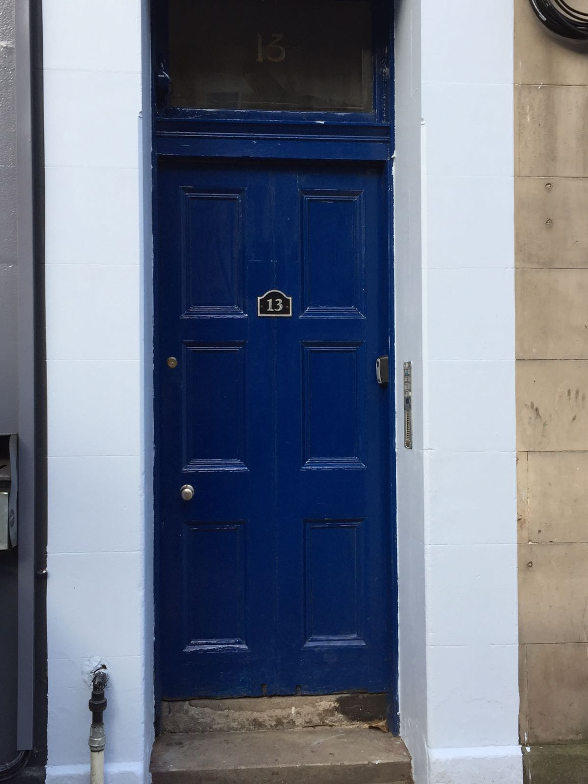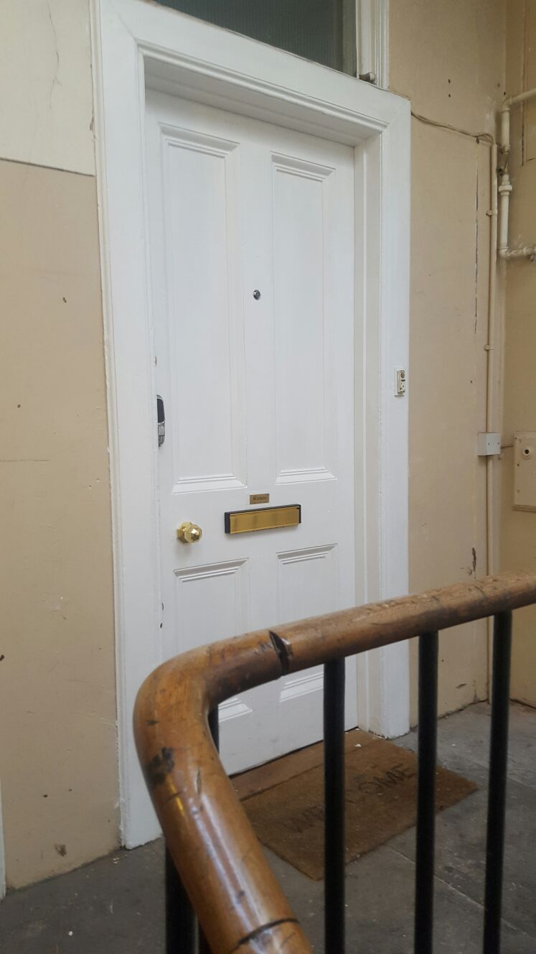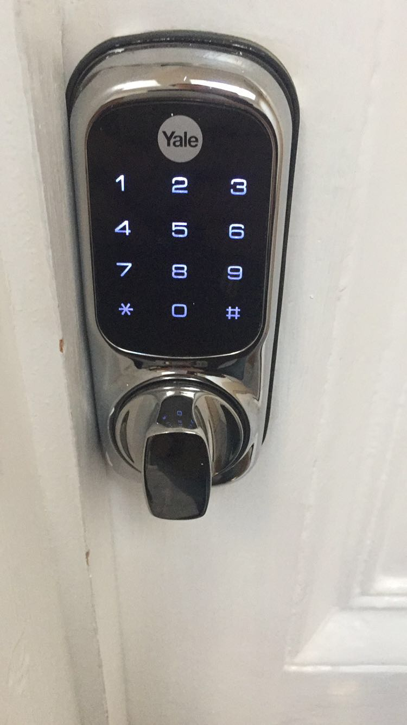
How to get to the apartment from the Airport

You have 3 easy options:

- Take the tram

The tram begins from Edinburgh airport at 6am, runs every 10 minutes, and ends at 11pm. It costs £5.50 for an adult, and £3 for a child. It is by far the most reliable and economical way into the city. Currently there is only one route so you don’t run the risk of taking the wrong tram.
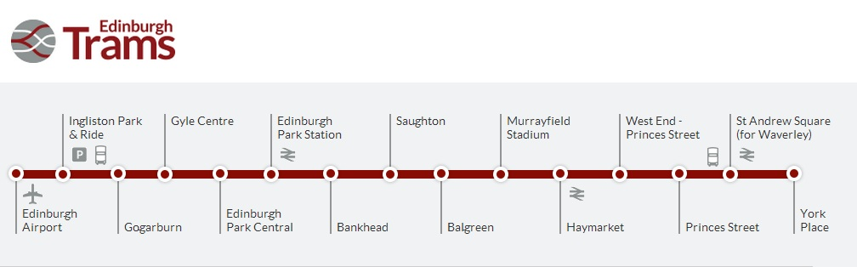

It takes approximately 30 minutes to get to West End - Princes Street which is the closest tram stop from my apartment. It is approximately 10 minute walk away.

Service Starts: 06:18 from Edinburgh Airport
Last end-to-end trams leave at: 22:48 from Edinburgh Airport

More information: https://edinburghtrams.com/


- Get a taxi

This is the most convenient option if you have heavy bags with you! The journey from the airport directly to the apartment will take approximately 20 minutes and 40-60 min during rush hour (8am – 10am and 3pm to 6pm. These are estimates. Please make sure you allow yourself enough time.

Uber taxis have recently started operating in Edinburgh and offer a cheaper alternative to standard city cabs.

- Take the bus

The blue Airlink (service 100) express bus is just outside when you exit the Airport and runs every 10 minutes to/from the city centre. It costs £4.50 for an adult, £2.00 for a child, and return tickets are available.
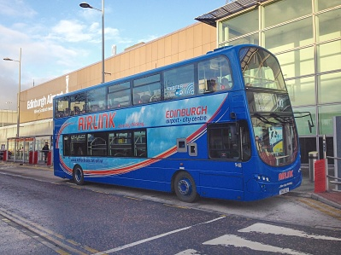

The journey to the city centre takes about 30 minutes and the bus stops at West End – Princess Street. My apartment is approximately 10 minute walk away.

THIS SERVICE RUNS 24/7 - every 10 minutes

More information: https://www.lothianbuses.com/our-services/airport-buses/

From Bus Stop AND Tram Stop WESTEND to the flat:
