13/3F2 Spittal Street Manual



Arrival Information

WIFI / INTERNET DETAILS

The house has free Wi-Fi. The details are:
ID: VM1073497
Password: vvrn7mdCyzrg

The service is provided for your enjoyment but you are responsible for safe and appropriate use and complying with all laws. If there is any loss of service, try resetting the router (located to the left of the TV in the living room) by switching it on and off at the wall, if this does not work then please contact us on Airbnb.

CHECK-IN TIME
Upon booking confirmation, you were sent a URL link with details of exactly how to check in. You will receive any codes you need 12 hours before arrival. Check-in time is 3pm. This is to allow us enough time to clean and prepare for your arrival.

You are welcome to drop off your luggage after 11:30 am but be aware that the flat won’t be ready for you to enjoy completely by yourself as the cleaner will still have to get the property ready for you.

Occasionally we can arrange an early check-in so please contact us if you will arrive early and we'll do our best, but without any promises! If you arrive early - there is plenty to keep you entertained in the city.

Please be respectful of our home and possessions and treat them with the same courtesy you would want others to treat yours. If there is anything we can do to make your stay more enjoyable please do not hesitate to contact us.

Departure Information

CHECK-OUT PROCESS
When you leave, please ensure the following simple tasks are done:
- take the rubbish out to the bins just outside on the street.
- If you have boosted the heating please put it back to a normal setting.
- wash your dishes, please don’t leave dirty plates and cups around.
- lock the house exactly as you found it, taking keys back exactly to where you retrieved them from.

CHECK-OUT TIME
Check-out time is strictly 11am. Should you require a later check-out we will do our best but you need to let us know beforehand. If we have guests arriving that day it will be almost impossible to offer a late check-out due to the cleaners needing to prepare for those guests.

CLEANING
You will find the house clean on arrival but please let us know if you are not satisfied. There is no cleaning service unless you have specifically requested / paid extra for this. On departure, it would be helpful if you could leave the house (particularly kitchen contents) clean and tidy when you leave.

Appliance Instructions

Please note there are manuals for all appliances in the top island drawer to the right of the pantry in the kitchen.

CENTRAL HEATING
The heating is controlled using the Honeywell thermostats on the shelf in the hallway. Simply use the up and down arrows to set your desired temperature. The boiler is located in the pantry in the kitchen, you should not need to make any adjustments to this. Please also ensure all individual radiators are turned up fully at the valve. If there is no heating or hot water, please call us either on 07564397262 (Andy) or 07821544835 (Laura). If you can’t reach us please leave a voicemail and we will contact you ASAP.

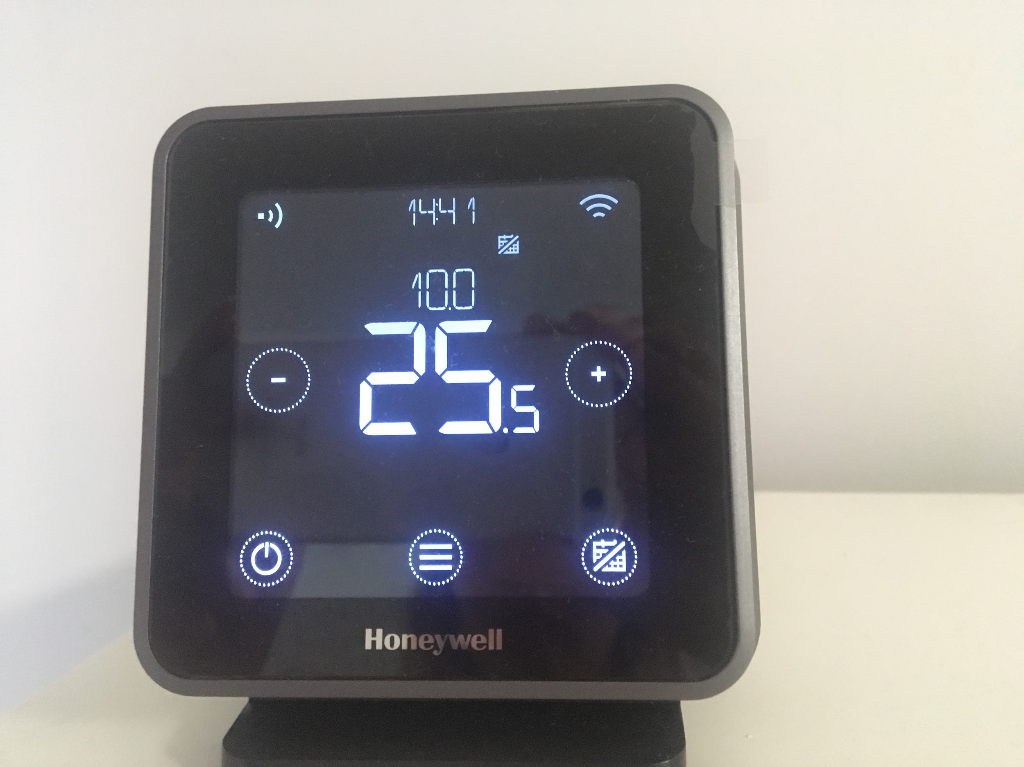

KITCHEN EQUIPMENT
The Fridge/freezer:
You should not need to adjust any settings. If you run into any difficulties (e.g. it's not cooling efficiently) please let us know.

The Hob:
Choose which hob you want to use out of the eight dials. Press the dial down while turning and press the ignite button to the far right. Hold the dial down for a few seconds before letting go.

To use the oven, just turn the appropriate dials as the oven element is electric, unlike the gas hob.

Kettle
Make sure it is plugged in and the isolator switch for the plug is switched on. Then press the switch at the back of the kettle down, the light indicates when it is on.

Toaster
The toaster is straightforward to use, simply slide the lever down to activate it.

LAUNDRY FACILITIES

Washing machine:
Located in the pantry in the kitchen. Before using, press the button on the pump unit for a few seconds (located to the left of the machine, on the floor). Turn the dial to select your desired programme and then press the ‘Start’ button. We do not provide detergent as a standard, due to everyone having their own preferences, allergies etc. It can be bought at the nearest supermarket.

Drying rack/Iron/Ironing board:
Located in the pantry in the kitchen.

Enjoying your time inside

BREAKAGES
We understand that sometimes accidents happen! Should you break anything please let us know immediately - if it's minor we usually won't charge. If it's a larger issue (e.g. the TV screen!) we would like to agree the cost with you before you leave to avoid any issues later, this is processed through the resolution centre in Airbnb. Thank you!

TELEVISION
Use the Samsung remote to turn the TV on. Then use the Virgin Media remote to turn the TiVo on. You can flick between several channels using the ‘Ch’ up and down arrows. To access streaming services such as Netflix and BBC iPlayer, press the HOME button on the Virgin Media remote. Go to ‘Apps & Games’ and then ‘All apps’.

Other useful information

LIGHTS
All lights in the property are on dimmer switches and can be raised/lowered as you desire.
HAIRDRYER
There is a hairdryer provided in the drawer under the sink in the main bathroom.

FIRST AID
There is a first aid kit for minor injuries located in the top left cupboard in the kitchen.
INTERCOM
The intercom system is by the front door. You can open the ground floor door by lifting the handset and pressing the buzzer.
MAIN SWITCHBOARD
Should there be a power cut to the flat, the electricity control panels is located in the cupboard in the hallway, just to the right of the main door. There is a ladder in the hallway cupboard if you need to access the switchboard. Check that all the switches are flicked up. Any switches pointing down are the ones that have been tripped, simply flick the switch back up but please do not force it.

Be aware that after a power cut you will have to switch on the socket in the living room which provides power for TV, WIFI and Music.

Safety information

999 & 112 – The main emergency numbers
Both are the emergency number for police, ambulance, fire brigade, coastguard, cliff rescue, mountain rescue, cave rescue, etc. Note the important word ‘EMERGENCY’. This number should be used only when urgent attendance by the emergency services is required – for example someone is seriously ill or injured, or a crime in progress.
Calls are free, and can be dialled from a locked mobile phone.

111 – The non-emergency medical number
Call 111 and speak to a highly trained adviser, supported by healthcare professionals. They will ask you a series of questions to assess your symptoms and immediately direct you to the best medical care for you. NHS 111 is available 24 hours a day, 365 days a year. Calls are free from landlines and mobile phones
Use this for illnesses and minor injuries which aren’t serious, but you would like some advice on what to do next.

+44 7564 397 262 - Major issues in property number
This number should be used in case of an emergency in the property, e.g. a pipe breaking, toilet flooding, etc.

Local Shops

Sainsbury’s Local
Westport. 0.1 miles / 3 minutes walk
Tesco Express
Earl Grey Street. 0.2 miles / 4 minutes walk

You’ll find several nice bars and restaurants along Lothian Road - we can recommend The Hanging Bat and The Beer Kitchen!

Local Transport

Bus Stops
Numerous bus stops are run by Lothian Buses, with routes all over the city. A hop-on, hop-off day ticket costs £4. You can buy your ticket on the bus, but be aware that exact fare is necessary as no change is provided and cards are not accepted yet. You can check out routes and plan your journey at lothianbuses.co.uk or using Google Maps.
Trams
There are tram station at Shandwick Place, Princes Street, St Andrew Square and York Place which goes to/from the airport and costs £5.50 for an adult single ticket to the airport, and £8.50 for a return.
Taxis
Edinburgh is known for its black taxi cabs which offer safe transport around the city for locals and tourists. Download the GETT Taxi app for a reliable black cab service everywhere in the city, or call 0131 228 1211.

